Report from analysis of public procurement portals and e – solutions applied in five EU countries, containing recommendations for potential enhancements of the e-Procurement in Serbia

January 2025

TABLE OF CONTENTS

Introduction 3

Italy 4

Organization of the E-Procurement System 4

E-Procurement system components 5

Timeline of development of the e-Procurement system in Italy 6

Advantages and limitations of the Italian e-Procurement system 6

Conclusion 7

Estonia 8

Background and Development of the E-Procurement System 8

Key Features and Functionalities 8

Electronic catalogue 10

Challenges and Future Directions 11

Croatia 12

Scope and Features of EOJN RH 12

Institutional Oversight and Responsibilities 12

User Costs and Optional Services 13

Core Modules of EOJN RH 13

Advantages and Disadvantages of EOJN RH 15

Belgium 16

Main functionalities for Economic Operators on BOSA system 16

Additional Features / support 19

Portugal 20

Key Features of Portugal's e-Procurement System 20

Impact, Benefits 20

Challenges and Areas for Improvement 21

Recommendations for future enhancements of the Public Procurement Portal in Serbia 22

# Introduction

In recent years, digital transformation has become a cornerstone of public sector modernization, with e-Procurement solutions emerging as vital tools to enhance efficiency, transparency, and accountability in public procurement processes. The European Union (EU) has been at the forefront of promoting digital procurement practices, fostering an environment of innovation and standardization across member states.

This report aims to provide a comprehensive analysis of e-Procurement solutions in five EU countries: Italy, Croatia, Portugal, Belgium, and Estonia. By examining the functionalities, organizational frameworks, regulatory landscapes, and strategic priorities of these solutions, the report seeks to identify best practices and highlight areas for improvement from which Serbia can benefit.

The selection of these countries reflects a diverse range of experiences and approaches to implementing e-Procurement systems. Each country offers unique insights into the challenges and opportunities associated with digitalizing procurement processes within the context of its legal, organizational, and cultural environment. Italy and Portugal, for instance, have focused on developing robust platforms to address inefficiencies in public spending, while Estonia is renowned for its leadership in digital governance and interoperability. Croatia has recently launched a new e-Procurement platform focusing on end-to-end procurement and Belgium contributes from additional perspectives such as emphasizing regional and cross-border collaboration.

This report is structured as follows:

1. **Functional Analysis**: An exploration of the core functionalities and features of e-Procurement solutions in the selected countries, including their user interfaces, process automation capabilities, and integration with other systems.
2. **Organizational Perspectives**: A discussion of the institutional arrangements and governance models that support the implementation and management of e-Procurement platforms.
3. **Regulatory Frameworks**: An examination of the legislative and policy frameworks that govern e-Procurement, including compliance with EU directives and national regulations.
4. **Strategic Insights**: An analysis of the strategic objectives driving e-Procurement adoption, such as fostering transparency, reducing costs, and enhancing market accessibility for small and medium enterprises (SMEs).

Through this analysis, the report aims to contribute to a deeper understanding of the factors influencing the success of e-Procurement initiatives and to provide actionable recommendations for policymakers, practitioners, and stakeholders across the EU.

# Italy

Italy's e-Procurement system is a sophisticated and comprehensive framework designed to streamline and digitize the procurement processes within the public sector. This system aims to enhance transparency, efficiency, and competitiveness in public procurement, aligning with the broader goals of modernizing public administration and fostering economic growth.

## Organization of the E-Procurement System

Several key institutions play crucial roles in establishing and managing Italy's e-Procurement system:

**Consip**: Consip is an Italian state-owned company that provides frameworks and consultation for the procurement of public goods and services. It was set up as a joint-stock company in 1997 and is owned by Italy's Ministry of Economy and Finance (MEF), which is the sole shareholder. The company operates in keeping with the MEF's strategic goals, working exclusively to serve the public administration.

Consip’s activities involve three main areas:

* as central purchasing body, it runs the Programme for the rationalisation of public administration purchases, through the use of ICT and innovative procurement tools: framework contracts, e-marketplace for public administration, framework agreements, dynamic purchasing system, ASP tenders (Central Procurement Area).
* based on specific agreements, it supports the individual PAs in all areas throughout the procurement process (Vertical Procurement Area).
* through legal provisions and/or administrative acts, it develops programmes that make use of its know-how in the area of procurement, as well as its ability to manage complex and innovative projects in the sphere of Public Administration

As the central purchasing body, Consip manages the MEPA platform and oversees the implementation of e-Procurement practices. Consip ensures that the procurement processes are efficient, transparent, and compliant with national and European regulations. The focus of the e-Procurement strategy in Italy has started from the perspective of more efficient public spending in public procurement. Therefore, Consip is therefore a pioneer in e-Procurement initiatives as well as the know-how authority for e-Procurement in Italy.

**ANAC (National Anti-Corruption Authority)**: ANAC is responsible for monitoring and regulating public procurement to prevent corruption and ensure compliance with legal standards. ANAC manages the centralized contract registry of Italy - BNAC and provides guidelines for the proper conduct of procurement activities. Additionally, ANAC provides “Virtual company dossier” services for checking the economic operators in the process of tender evaluation, providing integration with various (20+) registries in Italy and acting as a proxy for collection of evidence for economic operators (similarly to APR in Serbia).

**AgID (Agency for Digital Italy)**: AgID plays a pivotal role in the digital transformation of public procurement. It establishes technical guidelines, certifies e-Procurement platforms, and ensures interoperability between different components of the system. AgID also acts as the PEPPOL Authority, facilitating the electronic exchange of documents in procurement processes.

In Italy, the contracting authorities have the possibility to choose their e-Procurement system of preference. Currently, there are about > 45 platforms used, but not all cover the procurement life cycle The AgID has established a comprehensive guideline for functional, technical, and organizational requirements and provides a certification process for a certain platform to be certified and approved for usage by the contracting authorities.

## E-Procurement system components

The e-Procurement system in Italy is organized into several key components and platforms, each serving specific functions within the procurement lifecycle. These components include:

**MePA (Public Administrations’ e-Marketplace)**:

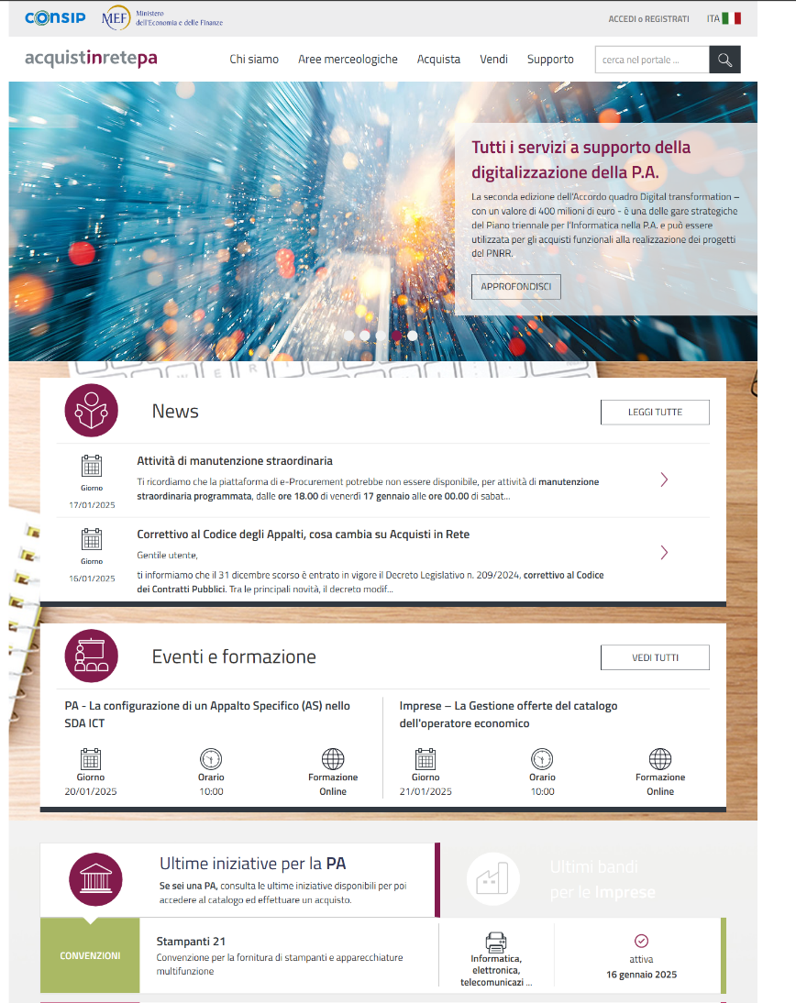This component is part of the broader e-Procurement infrastructure, facilitating the management and execution of procurement processes. It primarily focuses on the functionalities of e-Catalogue for which the contracting authorities can buy goods and services from certified economic operators. Its target are low-value procurements of standardized goods and services in a simplified manger, by using “e-Marketplace” functionalities. Additionally, MePA supports also simplified e-Procurement procedures for awarding the low value contracts of non-standardized goods and services. The functionalities include:

* open-like procedure (RFQ)
* Direct purchase from a pre-selected economic operator (DP)
* Direct negotiation with a set of certain economic operators (DN).

**Framework agreements and SDapa**: allows public administrations to procure goods and services through a simplified and flexible process, enhancing the efficiency of procurement activities by using already established framework agreements and dynamic purchasing systems for general procurement categories. These framework agreements and Dynamic purchasing systems are managed / governed by Consip and contracting authorities use this centralized procurements for the purchase of goods, services and works in accordance with the government decision / decree for mandatory centralization of procurement.

**Gare in ASP**: This platform supports the management of procurements, providing tools for the publication, management, and evaluation of bids and full life-cycle above-threshold procurements. The procurements are carried out independently by the contracting authorities, but Consip can also execute procurement procedures on behalf of the contracting authorities in “procurement-as-a-service” model.

**BNAC**: The National Database of Public Contracts (BNAC), managed by ANAX is a centralized repository that stores information on public contracts, ensuring transparency and accessibility of procurement data. It includes all notices about procurements on national level and serves as a central hub for finding tender opportunities for economic operators. Additionally, all public contracts are transmitted to the central database and exposed as open-data enabling powerful data analysis tools for public expenditure.

## Timeline of development of the e-Procurement system in Italy

* 1999: Italy begins the digitalization of public administration procurement processes, adopting various e-Procurement models.
* 2002: Introduction of online auctions and marketplaces to enhance transparency, competitiveness, and efficiency in public procurement.
* 2013: Ministerial Decree 55/2013 sets out the rules for electronic invoicing through the Exchange System.
* 2015: Electronic invoicing becomes mandatory for all levels of public administrations.
* 2016: EU Directives on Public Procurement are transposed into national law (D.Lgs 50/2016), integrating national e-Procurement systems into a single interoperable network.
* 2016: Publication of technical rules for e-Procurement systems, paving the way for the adoption of the Peppol Network for interoperability.
* 2017: AgID becomes the Peppol Authority, overseeing the implementation and management of the Peppol framework in Italy.
* 2018: Legislative Decree No. 148 adopts the EU Directive on electronic invoicing for public procurement (2014/55/EU).
* 2019: Establishment of technical guidelines for the management of e-invoicing in line with European norms.
* 2024: The new Public Contracts Code (a set of provisions of law governing the award of public contracts in Italy) includes certification methods and technical guidelines for digital e-procurement platforms.

## Advantages and limitations of the Italian e-Procurement system

Advantages:

* Electronic Procurement in general has been recognized as one of the biggest drivers of the public procurement reform and means of reducing of the public expenditure in Italy which has benefited from significant cost savings by early adoption of e-Procurement.
* Using centralized procurement body as a centrally-positioned authority with know-how about e-Procurement and procurement in general has proven to be extremely effective model. The IT systems developed by the Consip has served as a role-model for other systems and general as was one of the pioneers in EU.
* Consip’s IT systems for e-procurement have been recognized as critical national infrastructure for national cybersecurity purposes with adequate amount of funding provided to maintain and upgrade the system
* Italy is exploring / experimenting with advanced technology in procurement processes, such as fully automated procurements carried out by the system itself, from the definition of needs to selection of the awarded economic operators. This approach has even already been legitimately provisioned in the government decree [D.lgs. n. 36/2023 (cod. contr.)](https://www.bosettiegatti.eu/info/norme/statali/2023_0036.htm#030)

Disadvantages:

* Fragmentation of the e-Procurement systems available in Italy is extremely high (> 45 platforms), which introduces additional burden on contracting authorities to choose, learn and finance the usage of such systems for their own purposes. Typically, contracting authorities must use multiple systems to successfully carry out all of their procurements. Because of this, there is a general strategy to further centralize procurements on the local government and municipalities level (as a sort of second-level of centralization) to reduce the administrative burden and costs. This approach has been driven by ANAC initiatives.
* Additionally, platforms which operate in e-Procurement landscape are certified but use different technologies, concepts and user experience. Economic operators who need to submit the tender are struggling because the platforms do not share a common standard.

## Conclusion

Italy's e-Procurement system represents a significant step towards modernizing public administration and enhancing the efficiency of public procurement. By leveraging digital tools and platforms, the system aims to streamline procurement processes, increase transparency, and foster a competitive market environment. The e-Procurement has been properly recognized as one of the pillars of the economy management in Italy and therefore is properly financed and managed. The collaborative efforts of Consip, ANAC, and AgID ensure that the system operates effectively, adhering to the highest standards of integrity and efficiency. However, high fragmentation of e-Procurement solutions available on the market make the whole system difficult and expensive to manage.

# Estonia

Estonia, often referred to as one of the most digitally advanced nations in the world, has long been a pioneer in leveraging technology to enhance governance and public services. Among its many innovations, the e-Procurement system stands out as a cornerstone of its e-Governance framework, streamlining public procurement processes while ensuring transparency, efficiency, and inclusivity.

Organization of the e-Procurement system:

* **Ministry of Economic Affairs and its IT house (RIT)**– general IT policy and infrastructure in Estonia
* **Ministry of Finance** – public procurement policy, strategy, monitoring, supervision, consulting
* **State Shared Service Centre (RTK)** – Central Purchasing Body, since January 1, 2024 administration and helpdesk of Public Procurement Register
* **Centre of Registers and Information Systems (RIK)** – administration of e-catalogue (linked to Procurement Register)
* **IT house for the Ministry of Finance (RMIT)** – Central Purchasing Body for IT service procurements within the institutions of Ministry of Finance; maintenance, project management and technical support for Procurement Register

## Background and Development of the E-Procurement System

Estonia’s journey toward digital governance began in the 1990s. Recognizing the transformative potential of technology, the government prioritized the development of digital infrastructure, including e-Government initiatives. The e-Procurement system was launched as part of this broader strategy to digitize public services.

The system operates through a single, centralized online platform that enables government entities to procure goods and services while allowing businesses to participate in public tenders. By providing a transparent and standardized process, Estonia has minimized opportunities for corruption and reduced administrative burdens. The platform usage is free for all users.

**General procurement statistics 2023**

* Volume – up to 9000 procedures
* Value – up to 5 billion EUR
* 97% e-procurements
* On average 4,03 tenderers per competition

## Key Features and Functionalities

1. **Transparency and Accessibility:** The platform enables government entities to create and publish tender announcements, specifying requirements, deadlines, and evaluation criteria. Vendors can view and respond to these tenders through a streamlined submission process. The e-Procurement platform publishes all procurement-related information, including tender announcements, bidding processes, and contract awards. This openness ensures that all stakeholders have equal access to opportunities. The notices are automatically translated and transmitted in e-Forms for submission to the Central European Official Journal (TED)
2. **Bid Submission and Evaluation:** Vendors can submit their bids electronically, complete with required documentation. The system supports automated bid evaluation based on predefined criteria, reducing the potential for human bias and errors.
3. **Contract Management:** Once a bid is awarded, the platform facilitates the creation and management of contracts. Users can monitor contract performance, track milestones, and manage amendments in real-time.
4. **Document Archiving:** The system maintains a digital archive of all procurement documents, including bids, contracts, and communication records. This ensures a robust audit trail and compliance with regulatory requirements.
5. **Real-Time Notifications and Alerts:** Users receive automated notifications for important updates, such as bid deadlines, contract awards, or required actions. This keeps stakeholders informed and reduces delays.
6. **Automation and Integration:** The system is integrated with other national e-Government services, such as th e-ID for centralized identity management, and X-Road data exchange platform. Automation of tasks like tender evaluation and contract management reduces human error and accelerates decision-making.
7. **Cost Efficiency:** By centralizing procurement processes, Estonia has significantly reduced administrative costs. The system also promotes competitive bidding, ensuring that public funds are used effectively. The specific centralized procurement module is used in the e-Procurement system which enables collection of needs and supports centralized framework agreements which the contracting authorities – users can consume and register individual contracts.
8. **Performance Analytics and Reporting:** The system offers detailed analytics and reporting tools, allowing government agencies to evaluate procurement efficiency, supplier performance, and cost savings over time.
9. **User-Friendly Interface:** The platform’s intuitive design allows both government officials and private sector participants to navigate it easily. Training programs and support services further enhance user experience.
10. **Sustainability Initiatives:** The system includes features that prioritize green procurement, encouraging environmentally friendly practices among economic operators. Several functionalities have been developed for stimulating green procurement, such as mandatory eco criteria for certain categories of goods.

## Electronic catalogue

Electronic catalogues have a specialized roles in the e-Procurement system.

Typically, electronic catalogues are related to the following procurement categories:

* Office supplies,
* IT equipment,
* Maintenance services,
* Professional services (consulting, training, etc.),
* Medicines.

**Key Features of Electronic Catalogues**

1. **Standardized Format**: Products and services are presented in a consistent format, including detailed descriptions, pricing, and terms of delivery.
2. **Search and Filtering Tools**: Users can easily search for items by category, supplier, price, or other attributes.
3. **Integration with Procurement Workflows**: Catalogues are embedded within the EPS, allowing seamless transition from browsing to ordering and contract management.
4. **Real-Time Updates**: Suppliers can update their catalogues to reflect changes in availability, pricing, or product specifications.
5. **Compliance Monitoring**: The system checks whether selected items meet predefined standards or procurement guidelines.

How do the e-Catalogues function?

**Catalogue Submission by Suppliers**:

* Suppliers submit their electronic catalogues for approval.
* These catalogues are reviewed to ensure compliance with public procurement laws and the platform's requirements.

**Catalogue Approval**:

* Once approved, the catalogues become accessible to contracting authorities through the EPS.

**Selection and Ordering**:

* Contracting authorities browse the catalogues, select required goods or services, and place purchase orders directly.
* Purchase orders can be made under framework agreements or other simplified procurement procedures.

**Post-Order Processing**:

* The system facilitates order confirmation, invoicing, and payment tracking.
* Contracting authorities can monitor delivery performance and supplier compliance.

## Challenges and Future Directions

Despite its successes, Estonia’s e-Procurement system faces challenges such as ensuring cybersecurity, maintaining interoperability with international systems, and addressing the digital divide. Efforts are underway to enhance the platform’s resilience against cyber threats and to expand its capabilities for cross-border procurement within the European Union.

Looking forward, Estonia aims to further refine its e-Procurement system by incorporating artificial intelligence (AI) and advanced analytics. These technologies could improve tender evaluation, detect irregularities, and forecast procurement needs more accurately. Additionally, ongoing efforts to educate users and improve digital literacy will ensure that the system remains inclusive and accessible.

# Croatia

In 2024, Croatia launched a new centralized e-Procurement system (EOJN RH) to replace its outdated platform and align with the EU's updated eForms notice system. The modernization reflects Croatia’s commitment to improving public procurement processes, ensuring greater transparency, efficiency, and compliance with European Union Directives. EOJN RH facilitates the entire public procurement lifecycle, from planning and publishing notices to managing contracts and monitoring procurement outcomes.

## Scope and Features of EOJN RH

The EOJN RH platform is fully compliant with EU procurement directives and encompasses a wide range of procurement types, including:

* **Public Procurement Procedures:** Covers general and sectoral procurement conducted through electronic means.
* **Concessions:** Enables the management of contracts for public infrastructure and services.
* **Defense and Security Procurement:** Addresses specialized requirements for national defense and security needs.
* **Lex Specialis Procurement:** Tailored for reconstruction projects governed by the "Law on the Reconstruction of Buildings Damaged by Earthquakes."
* **Simple Procurement:** Provides an optional framework for below-threshold procurements ("micro-procurement"), enabling voluntary use of the platform.

## Institutional Oversight and Responsibilities

Several key institutions ensure the effective operation and governance of EOJN RH:

1. **Ministry of Economic Development:**
   * Oversees public procurement legislation.
   * Acts as the data owner of procurement information generated through the platform.
2. **Ministry of Finance:**
   * Supervises concessions and their implementation.
3. **Ministry of Planning, Construction, and State Assets:**
   * Governs reconstruction activities for earthquake-damaged structures.
4. **Official Gazette (Narodne novine d.d.):**
   * Operates the EOJN RH platform and provides user support through a helpdesk.
   * Implements system enhancements and processes change requests.

## User Costs and Optional Services

**For Economic Operators:**

* **Free of Charge Access:** The system is available free of charge to economic operators, ensuring accessibility for all potential bidders.
* **Optional Advanced Services:**
  + Advanced notification features (e.g., custom alerts).
  + Access to APIs exposing raw procurement data, typically for commercial service providers.

**For Contracting Authorities:**

* **Mandatory Fees:** Authorities pay a per-procurement fee to the Official Gazette for system usage.
* **Optional Modules:** Access to "Simple Procurement" features, although its use is not mandatory.

## Core Modules of EOJN RH

The EOJN RH system is organized into 13 key modules, each designed to address specific aspects of the procurement lifecycle:

1. **E-Planning Module:**
   * Supports annual procurement planning, including below-threshold procurements.
2. **Prior Consultations Module:**
   * Enables contracting authorities to publish draft procurement documents.
   * Facilitates public consultations and market feedback prior to official tender announcements.
3. **E-Noticing & E-Access Modules:**
   * Simplifies the preparation, submission, and publication of notices using EU-compliant eForms.
   * Automates procurement document generation based on input data.
4. **Q&A Module:**
   * Provides a platform for handling bidder questions and responses during the consultation and procurement phases.
5. **E-ESPD Module:**
   * Integrates the creation and exchange of European Single Procurement Document (ESPD) requests and responses into the tender process.
6. **E-Submission Module:**
   * Facilitates the secure electronic submission of tenders, participation requests, and design competition entries.
   * Includes automated tender opening features post-deadline.
7. **E-Communication Module:**
   * Supports communication between bidders and contracting authorities after the tender submission phase.
8. **E-Evaluation & Award Module:**
   * Automates evaluation processes, including:
     + Cross-referencing exclusion grounds with registries (e.g., trade, tax, and criminal records).
     + Assessing technical and selection criteria.
     + Automating ranking based on award criteria.
   * Generates evaluation minutes, award decisions, and cancellation notices.
9. **E-Contract Management Module:**
   * Tracks contracts and framework agreements through their lifecycle, including amendments and terminations.
10. **E-Framework Agreements Module:**
    * Manages centralized procurement schemes, mini-competitions, and decentralized contracting processes.
11. **E-Complaints Module:**
    * Handles end-to-end complaint management, ensuring transparency for all involved parties.
12. **External APIs:**
    * Supports integration for open data access, commercial service providers, and ERP systems used by contracting authorities.
13. **Statistics & Analytics Module:**
    * Offers robust reporting and statistical tools to monitor procurement trends and outcomes.

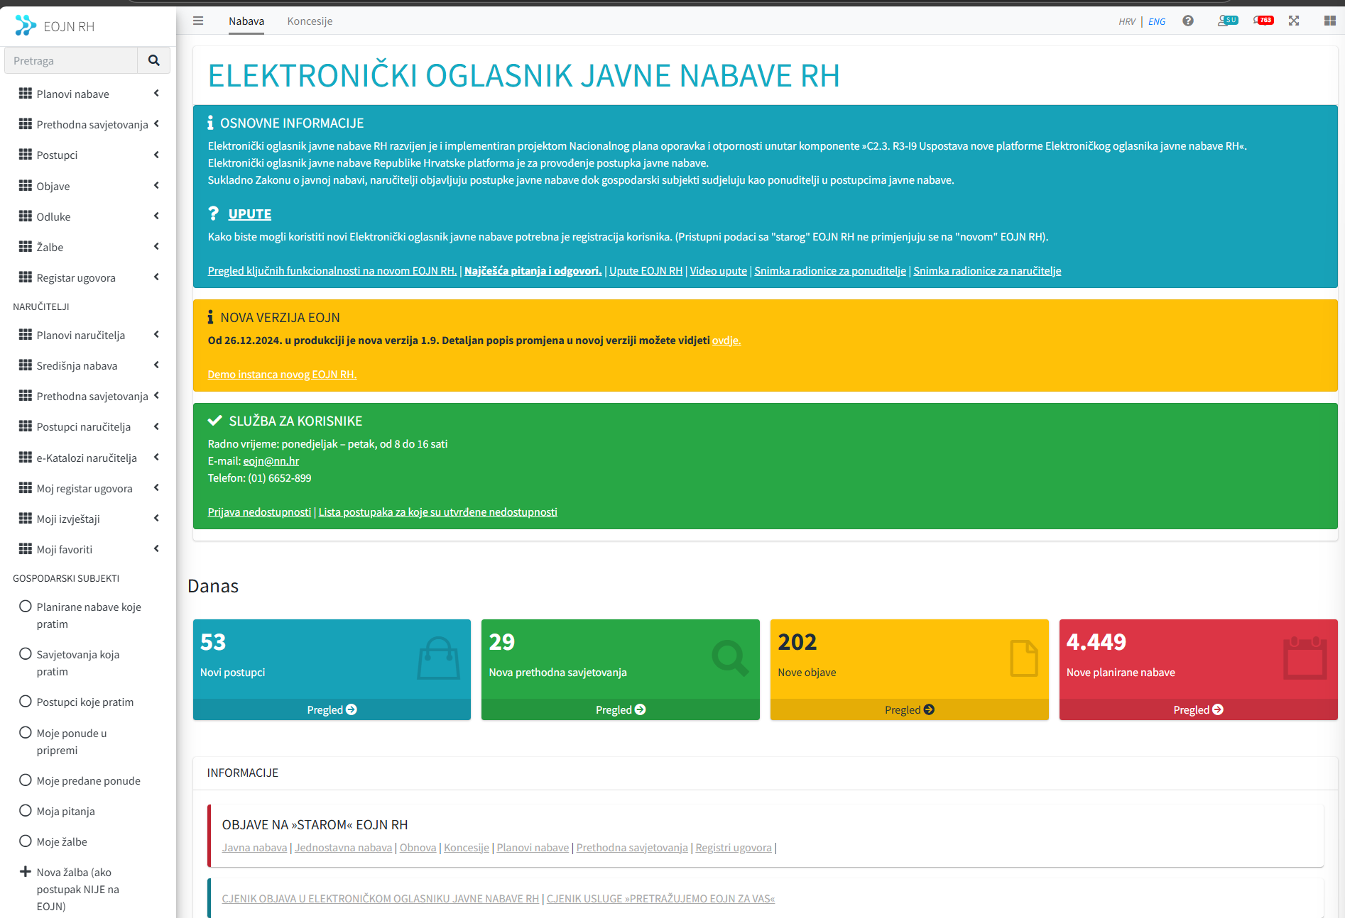

## Advantages and Disadvantages of EOJN RH

**Advantages:**

* **Centralized Platform:** Streamlines access for all participants with a modern, user-friendly interface and comprehensive user guides.
* **Future-Proof Compliance:** Early adoption of EU eForms ensures alignment with evolving EU standards.
* **Transparency:** Enhances oversight by providing accessible, structured data and automating compliance checks.

**Disadvantages:**

* **Lack of Integrated E-Invoicing:** The absence of e-invoicing integration limits the platform’s ability to monitor contract execution effectively.
* **Complex Regulatory Framework:** Outdated secondary legislation and rigid regulations often complicate processes for end users, increasing administrative burdens.
* **User Costs:** Contracting authorities face mandatory fees for platform use, adding financial strain to public institutions.

# Belgium

The BOSA e-Procurement platform in Belgium offers a comprehensive suite of functionalities tailored to streamline public procurement processes for both economic operators and contracting authorities.

As a single e-Procurement Platform in Belgium, BOSA system is managed by Federal Public Service Policy & Support, organization created in 2017 that assists the government and supports federal organisations in various areas: IT, HR, organisational control and integrity policy, budget, accounting and public procurement. It’s organized in several directorates, where public procurement is a part of Federal account and public procurement system. Roles of the FPS Procurement area includes following activities:

* Coordination, implementation and monitoring an effective and efficient public procurement policy for the federal administration
* Providing assistance to federal government buyers by:
  + providing legal advice on public procurement
  + making available standard documents
  + providing information sessions and training and offering support during projects
  + capturing needs and volumes, analysing contracts, gathering information on suppliers and proposing bundled contracts
  + managing grouped contracts as a central public procurement office
  + assisting in the drafting of public procurement documents.
* Monitoring and developing e-Procurement, the platform for digitalising public procurement, and supporting all Belgian contracting authorities and companies (national and international) using the platform.

The FPS has developed the e-Procurement system with end-to-end functionalities for e-Procurement and server both the economic operators and contracting authorities as a central platform for public procurements. Additionally, there are additional users of the system, such as civil society, Federal government and supervision authorities.

## Main functionalities for Economic Operators on BOSA system

1. **Registration and User Management:**
   * **User Account Creation:** Economic operators can create individual user accounts, which are linked to their company's profile. This setup allows multiple users from the same organization to manage procurement activities collaboratively.
   * **Role Assignment:** Administrators within a company can assign specific roles and permissions to users, ensuring appropriate access levels based on responsibilities.
2. **Tender Participation:**
   * **Bid Submission:** The platform provides a step-by-step guide for submitting bids electronically, ensuring that all required documents are uploaded and properly formatted.
   * **Digital Signatures:** To enhance security and authenticity, the system supports digital signatures, allowing operators to sign documents electronically before submission.
3. **Communication and Clarifications:**
   * **Q&A Module:** Economic operators can submit questions regarding specific tenders directly through the platform, facilitating clear communication with contracting authorities.
   * **Notification System:** Operators receive real-time alerts about tender updates, deadlines, and responses to their queries, ensuring they remain informed throughout the procurement process.

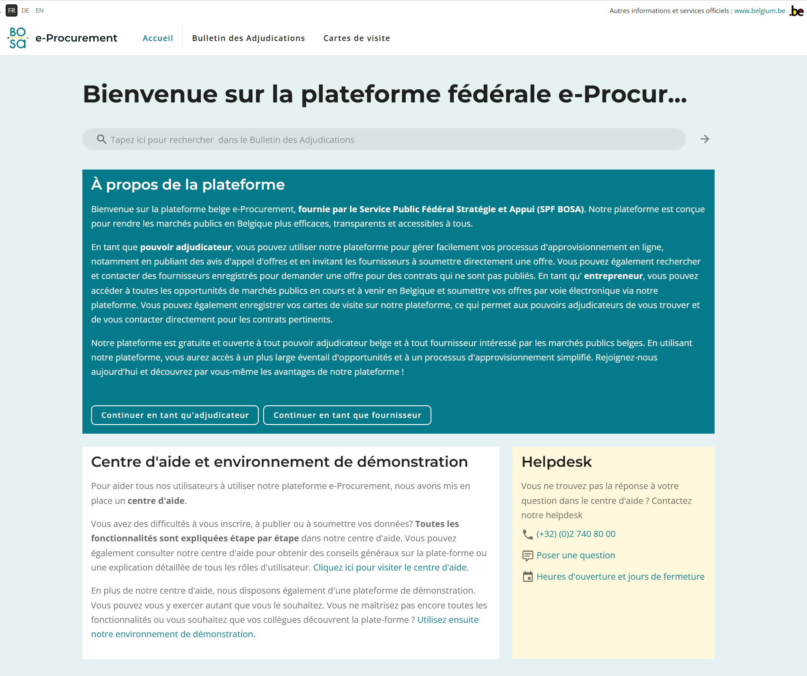

**Functionalities for Contracting Authorities:**

1. **Tender Creation and Management:**
   * **Template Utilization:** The platform offers customizable templates for drafting tender documents, ensuring consistency and compliance with legal standards.
   * **Document Publishing:** Contracting authorities can publish tender documents directly to the platform, making them accessible to all registered economic operators.
2. **Bid Evaluation:**
   * **Automated Evaluation Tools:** The system includes functionalities that assist in the assessment of received bids, allowing for the application of predefined criteria and scoring mechanisms.
   * **Audit Trails:** Every action taken during the evaluation process is logged, providing a transparent record for auditing purposes.
3. **Contract Awarding:**
   * **Notification of Results:** Authorities can inform bidders of the outcome directly through the platform, ensuring timely and documented communication.
   * **Feedback Provision:** The system allows contracting authorities to provide detailed feedback to unsuccessful bidders, promoting transparency and opportunities for improvement.
4. **e-Catalogue Functionalities**

**For Economic Operators:**

1. **Catalogue Creation and Management:**
   * **Product and Service Listing:** Economic operators can create detailed catalogues featuring their products and services, complete with descriptions, specifications, and pricing.
   * **Real-Time Updates:** The system allows suppliers to update their catalogues in real-time, ensuring that contracting authorities have access to the most current information.
2. **Integration with e-Tendering:**
   * **Seamless Bid Submission:** Suppliers can link their catalogues directly to specific tenders, facilitating a streamlined and efficient bid submission process.
3. **Order Management:**
   * **Electronic Order Receipt:** Upon contract award, suppliers receive electronic orders through the system, enabling prompt order processing and fulfillment.

**For Contracting Authorities:**

1. **Catalogue Access and Search:**
   * **Advanced Search Capabilities:** Authorities can search supplier catalogues using various filters such as product category, price range, and supplier ratings, aiding in informed decision-making.
2. **Direct Ordering:**
   * **Simplified Procurement:** For certain procurement procedures, authorities can place orders directly from supplier catalogues, expediting the purchasing process.
3. **Contract Compliance Monitoring:**
   * **Automated Checks:** The system monitors orders against contract terms to ensure compliance with agreed-upon conditions, reducing the risk of discrepancies.

**Advantages of the e-Catalogue System**

* **Efficiency:** Reduces procurement cycle times by enabling direct ordering and minimizing the need for repetitive data entry.
* **Transparency:** Provides clear visibility into available products and services, fostering fair competition among suppliers.
* **Accuracy:** Real-time updates ensure that all parties have access to the most accurate and current information, reducing errors.
* **Cost Savings:** Streamlines processes and reduces administrative burdens, leading to cost savings for both suppliers and contracting authorities.

## Additional Features / support

* **E-Invoicing Integration:** Aligned with the Peppol model, the platform supports electronic invoicing, enabling seamless financial transactions between suppliers and public authorities.
* **Helpdesk and Support:** Users have access to a dedicated help centre offering manuals, FAQs, and direct support to assist with any challenges encountered on the platform.

These detailed functionalities underscore the BOSA e-Procurement platform's commitment to enhancing efficiency, transparency, and user-friendliness in Belgium's public procurement landscape.

The e-Catalogue module is an integral component of the BOSA e-Procurement system, contributing significantly to the modernization and efficiency of public procurement in Belgium.

# Portugal

Considered as an e-Procurement champion, Portugal is considered as one of the pioneers of modern e-Procurement system based upon the innovative concepts.

The journey towards a robust e-Procurement system in Portugal began in the early 2000s. The economic crisis of 2007-2008 acted as a catalyst for reform, prompting the government to overhaul its public procurement processes. In 2008, Portugal introduced a new Public Contracts Code (NPCC), which laid the foundation for mandatory electronic procurement for all public tenders above EUR 5000 from November 2009.

## Key Features of Portugal's e-Procurement System

1. **Centralized Database and Transparency**: The Institute of Public Markets, Real Estate, and Construction (IMPIC) manages a centralized database that consolidates all public procurement information. This database adheres to the Open Contracting Data Standard (OCDS), ensuring transparency across all stages of procurement—from tender to implementation
2. **Privately Run Platforms**: Unlike many of its EU counterparts, Portugal's e-Procurement system operates exclusively on privately run platforms in what is usually called a “hybrid” model. The commercial platforms compete to provide services to contracting authorities, fostering innovation and efficiency. The data is then consolidated and integrated via API-s to the central “database”.

.

1. **Central Purchasing Body**: The creation of the National Agency for Public Procurement (ANCP) and the Shared Services Entity for the Public Administration (ESPAP) has streamlined procurement processes. These bodies are tasked with ensuring transparency and economic efficiency
2. **Public Contracts Portal (BASE)**: The BASE portal serves as a comprehensive platform for public contracts, providing access to information about tenders, awards, contracts, and their implementation. This portal is a critical tool for ensuring accountability and transparency and functioning of the complete public procurement system because it centralizes all public-procurement notices in one place, making it possible for economic operators to find tender opportunities.

## Impact, Benefits

The implementation of e-Procurement in Portugal has yielded significant benefits:

**Cost Savings**: The digitization of procurement processes has led to measurable cost savings. Studies indicate total savings of up to 12% and price reductions of up to 20%.

**Increased Efficiency**: The use of electronic tools has streamlined procurement procedures, reducing the time and bureaucracy involved. This has made the procurement process more efficient and accessible.

**Enhanced Transparency**: The mandatory publication of procurement data has increased transparency, reducing the potential for corruption and ensuring fair competition.

## Challenges and Areas for Improvement

Despite its successes, Portugal's e-Procurement system faces some challenges:

1. **Electronic Signatures and Timestamps**: The requirements for electronic signatures and timestamps can be cumbersome and costly for users. The model relies on buying “signatures” and “stamps” in batches, and then using these stamps in certain processes, as a mandatory prerequisite. The pricing is based on the higher costs for higher volumes of procurements / tenders and presents sometimes hidden costs in the procurement process.
2. **Interoperability Issues**: There is a need for better coordination and interoperability between different e-Platforms, the BASE portal, and the Official Journal. The concept of using the “hybrid” model of having commercial platforms as client-facing systems is extremely difficult to coordinate with the central system which collects the data and presents them on the national level. Processes such as change management, introduction of new functionalities, extensions of the data sets exchanged among the systems are very tedious and difficult to coordinate between multiple system providers and therefore require well-up-front planning of changes.
3. **Quality and standards of the commercial e-Procurement systems**: Since there are multiple platforms using (acinGov, anoGov, ComprasPT, saphetygov, and VORTAL Gov) there are significant differences in functionalities as well as in quality of the service. Economic operators must learn to use various systems based upon the contracting authorities’ preferences, which can lead to additional administrative burden and limit / discourage competition. The standardization process is somewhat implemented by the certification process by IMPIC, which also implies that additional effort is needed to oversight the proper functioning and monitoring of the commercially available e-Procurement systems.
4. **Significant proportion of direct-award contracts:** The number of direct-award contracts in Portugal is shocking. The recent analysis of government procurement procedures by using OCDS data revealed that the more than 80% of government procedures are direct awards. A staggering 8% of all procedures were tendered and awarded in less than six days, and 20% in less than 10 days. In terms of efficiency, those are impressive figures. However, in terms of competition within the procurement market, the situation can only be described as disastrous.
5. **Data Coverage**: While Portugal publishes extensive procurement data, there is room for improvement in the coverage and detail of the data, particularly around contract procedure planning.

# Recommendations for future enhancements of the Public Procurement Portal in Serbia

Serbia has a very well-developed e-Procurement system with all the fundamentals in place. Recent SIGMA Monitoring Report for Public Administration in Serbia 2024 has noted a significant and continuous development of the e-Procurement system in Serbia with a very-well established support system (helpdesk) by giving Serbia very high scores to indicators related to the e-Procurement. However, various possible enhancements can be extrapolated from the use-cases of e-Procurement systems described in this document for Serbia, spanning from the functional side as well as to how the system is marketed and can be made more attractive to the business.

**Streamline Regulatory Reforms:**

* **Introduction of EU eForms**, as the next-generation noticing framework adopted in EU has been developed in EU countries. The eForms regulation follows a new concept of having a definition of data sets, attributes and business rules for the data in notices and on the other hand for the countries implementing e-Forms, the liberty in presenting the data towards their users. Eforms ensure future compatibility with the EU regulation in the field of public procurement, but also with other initiatives of the EU (green procurement, innovative procurement, socially responsible procurement, addressing the market distortions, etc.)
* **Enhance e-Invoicing legislation** to streamline the process of monitoring of the contract execution. Since there is no control mechanism established in the B2G for accepting the e-Invoices related to the public contracts, there is no established process for automatically collecting the invoice information on the public contracts. Examples of Belgium and Estonia show that the streamlined process of collecting the e-invoice provided information bound to the contracts from the contract registry can increase transparency and automate processes for contracting authorities
* Although the PPPs and concessions are published on the Public Procurement Portal in Serbia (with rudimentary functionalities), the general **harmonization of the regulatory framework for PPPs and concessions with EU acquis** is still lacking. Serbia could use its positive experience with the public procurement harmonization process and take similar approach of using the e-Procurement solution in place to onboard concession award procedures while adopting the EU standards along-the-way.

**Promote Wider Adoption:**

* In the case of Italy, a significant effort invested in the promotion of the e-Procurement system has given positive push towards the market resulting in greater market adoption and participation of economic operators in public procurements. However, one must be aware that aggressive marketing of the e-Procurement system will not by itself result in greater competition in public procurement, judging by the case of Portugal, marketed as one of the best-in-the-line systems having on the other hand, unusually high ratio of direct awards in the public procurement system.
* **Promote the e-Procurement development strategy** including the development of roadmap showcasing future initiatives and development and include wider audience in the consultation process of developing future versions of the e-Procurement solution, such as NGOs, market and other stakeholders. Cases of Italy and Belgium show that having a clear communication about future developments / enhancements of the e-Procurement system can result in more transparent process and often lead to system more tailored to the real needs of the end-users.
* Most of the platforms analyzed support electronic procurement processes for **procurements under the threshold** of applying the provisions of public procurement law. Serbia could benefit from such approach and use existing functionalities and infrastructure with smaller modifications and simplifications to support fully electronic process for micro-procurements. This would result in greater market uptake since the new economic operators would start to register and use the Public Procurement Portal, which could encourage using the system also for standard public procurements thus stimulating competition in public procurement

**Support Advanced Features:**

* Develop tools which would facilitate **the market research process** by using the existing platform and data already available on the platform. Croatia is an example which has (overly)formalized the process of market research and has some specific e-processes which contracting authorities use to include the market in the procurement preparation process;
* Introduction of **e-Marketplace combined with the e-Catalogues:** those solutions,examples which were identified in Italy, Estonia and Belgium, usually for low-valued goods and services, can simplify and make more transparent procurement for under-the-threshold-of-law procurements. Serbia could benefit from the extension of the e-Catalogues functionalities it already uses in the public procurements to extend the functionality to micro-procurements;
* Introduce **advanced technologies for automation of the processes** and **promote using of powerful technologies**, such as machine learning and text recognition to data mine the abundance of data already residing on the Public Procurement Portal.